Variable Moment of Inertia Model for the CUSF 6DOF Trajectory Simulator

Daniel Gibbons, Aerodynamics Team

Contents

1 Overview 2

1.1 Assumptions 2

1.2 Summary of model 2

2 Theory 3

2.1 Moments of inertia for basic shapes 3

2.2 Parallel axis theorem 3

2.3 Geometry 4

2.4 Data available from Joe Hunt’s motor_sim.py 4

2.5 Conventions 4

2.6 Rocket Shell 4

2.7 Liquid Fuel 5

2.8 Solid Fuel 6

References 6

# Overview

## Assumptions

* The vapour phase does not contribute to the moment of inertia.
* No sloshing occurs
* Fuel tank is a cylinder
* Liquids do not contribute to the moment of inertia of a rocket about its long axis (i.e. assume the liquids are inviscid, so they do not rotate with the rocket about the long axis).

## Summary of model

* Liquid fuel is represented by a cylinder, constant radius, with a height and density that changes with time.
* Solid fuel is modelled as an annular cylinder, constant density and outer radius, with an inner radius that increases with time.

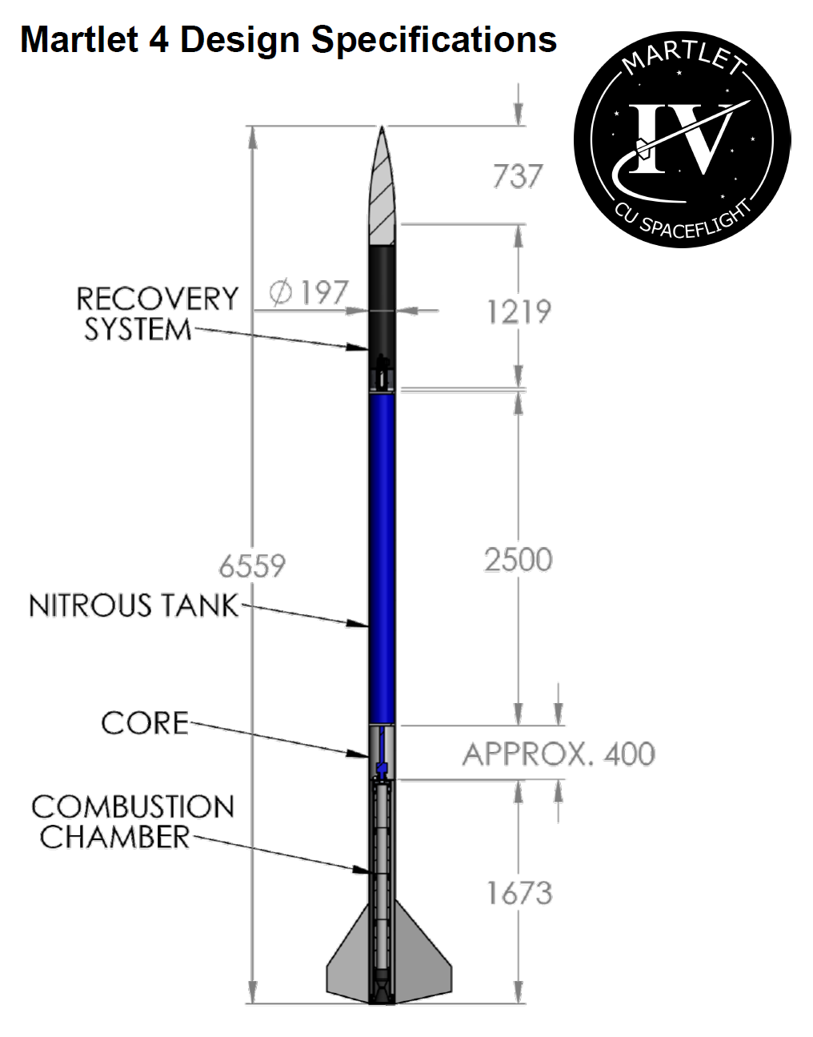

Figure 1: Martlet 4 geometry, from [1]

# Theory

## Moments of inertia for basic shapes

Equations obtained from the CUED Mechanics Databook [2], which also contains useful diagrams showing the geometry and definitions of symbols.

|  |  |  |
| --- | --- | --- |
| Shape | Moments of inertia | Definitions |
|  |  |  |
| Cylinder |  | radius |
| Annular cylinder |  | average radius  wall thickness  length |

## 

## Parallel axis theorem

Where are at the centre of mass.

## Geometry

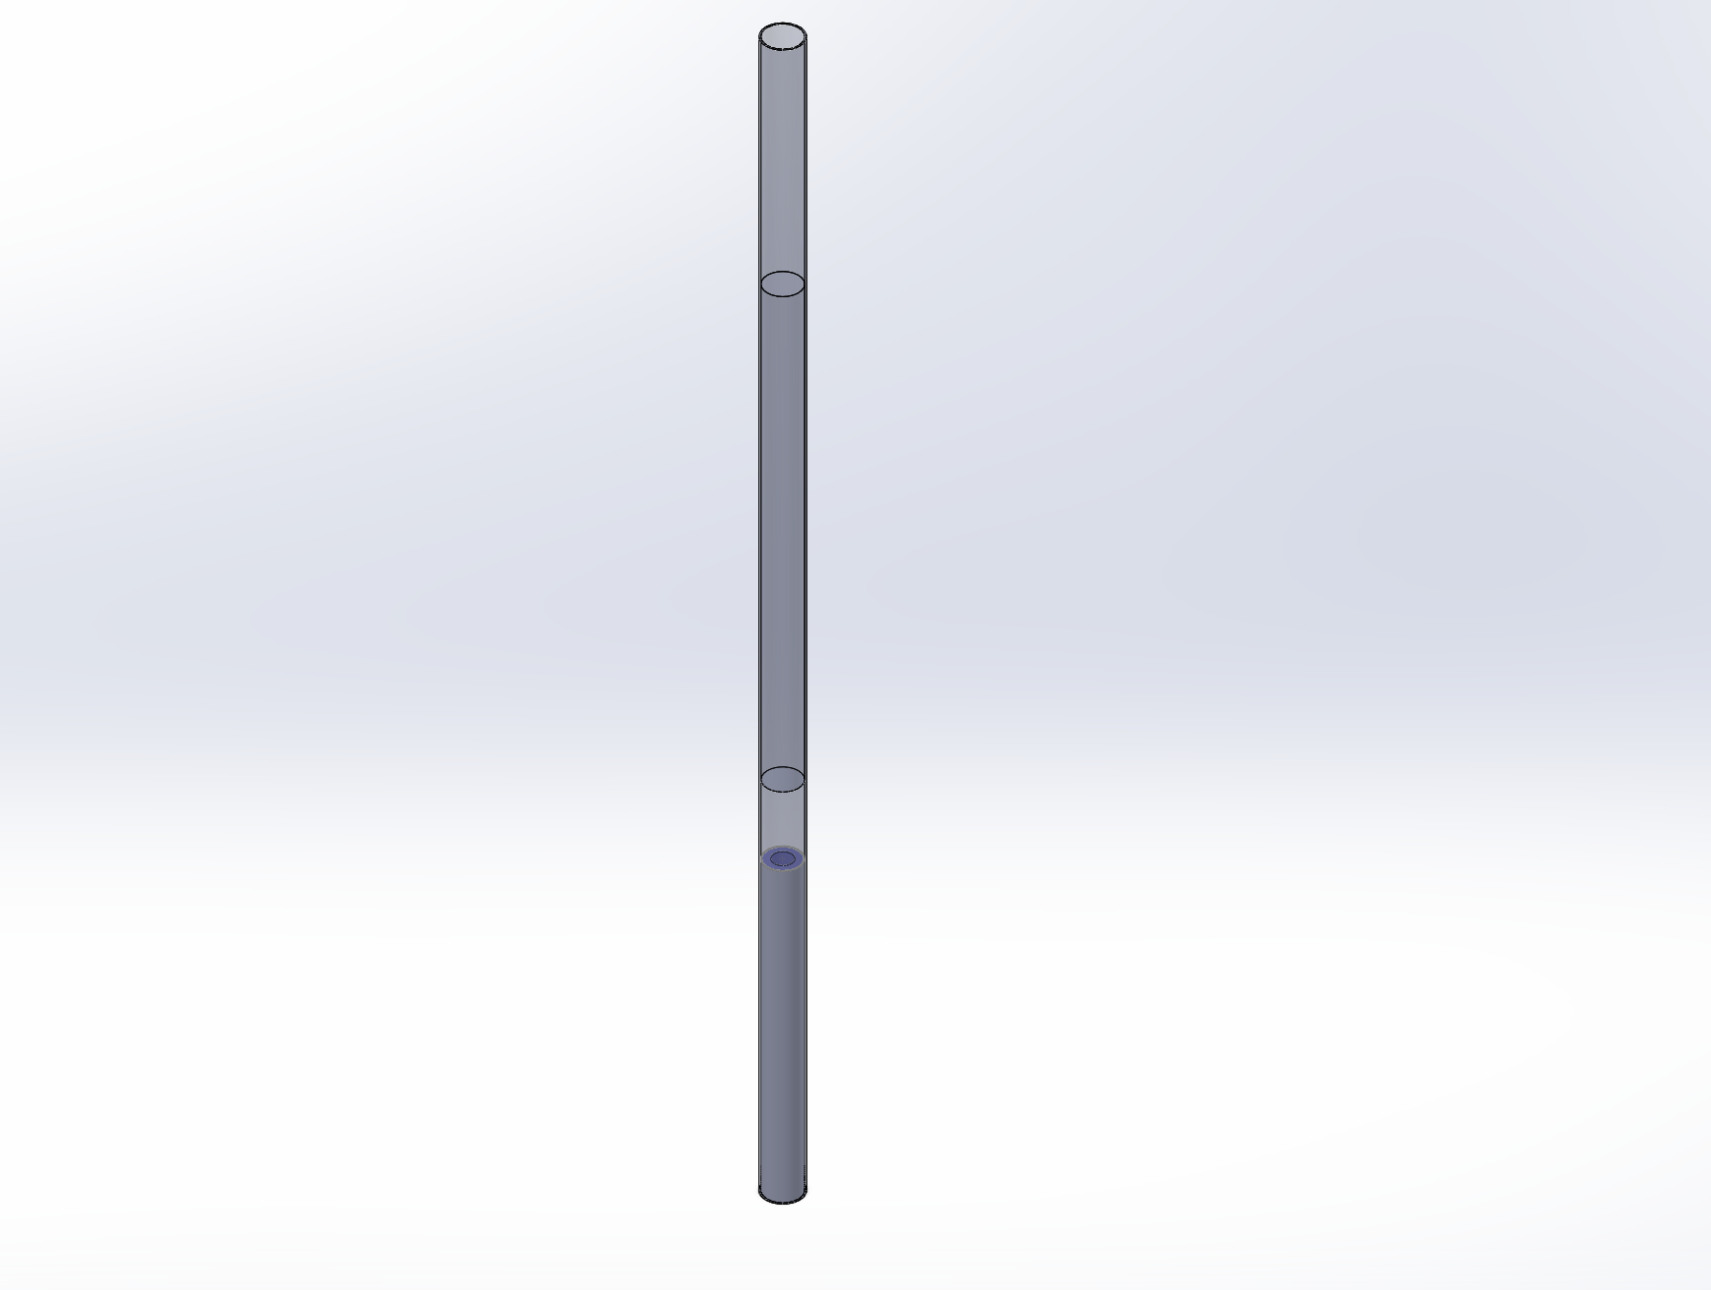

Rocket shell

(thin-walled cylinder)

Liquid fuel

(solid cylinder)

Solid fuel

(hollow cylinder)

datum

Figure 2: Diagram of the model used

## Data available from Joe Hunt’s motor_sim.py

The parameters output from Joe Hunt’s motor simulation gives us the following data (as a function of time where applicable):

* Liquid density, – referred to as *lden* in the code
* Liquid mass, – referred to as *lmass* in the code
* Solid fuel density (a constant) – referred to as *DENSITY_FUEL* in the code
* Solid fuel mass – referred to as *fuel_mass* in the code

It also contains information on the dimensions of various components.

|  |  |
| --- | --- |
| Dimension | Variable name in code |
|  |  |
| Solid fuel inner diameter | DIA_PORT |
| Solid fuel outer diameter | DIA_FUEL |
| Solid fuel length | LENGTH_PORT |
| Liquid tank volume | VOL_TANK |

## Conventions

* Positions are measured relative to the bottom of the rocket in Cartesian .
* always refers to a distance from the bottom of the rocket.
* is used to denote the position of a centre of mass.
* is around the individual centre of mass for a component.

## Rocket Shell

The rocket shell (i.e. structural parts that don’t vary with time) will be assumed to have a constant moment of inertia. For this analysis, we will model it as a thin cylindrical shell. However, it would be fairly easy to get values for more complicated shapes, by creating a model in SolidWorks, and then using SolidWorks to calculate the principal moments of inertia.

The subscript ‘shell’ refers to ‘rocket shell’.

## Liquid Fuel

The subscript ‘l’ refers to ‘liquid’. Note that:

* We will assume the liquid is inviscid, meaning that **it will not rotate with the rocket** about its long axis – hence .
* The mass of the liquid cylinder, , is a function of time.
* The length of the liquid cylinder, , is a function of time.
* is the centre of mass at .
* is the length of the cylinder at .

Since it’s modelled as a solid cylinder:

|  |
| --- |
|  |

Geometry variation with time:

|  |
| --- |
|  |

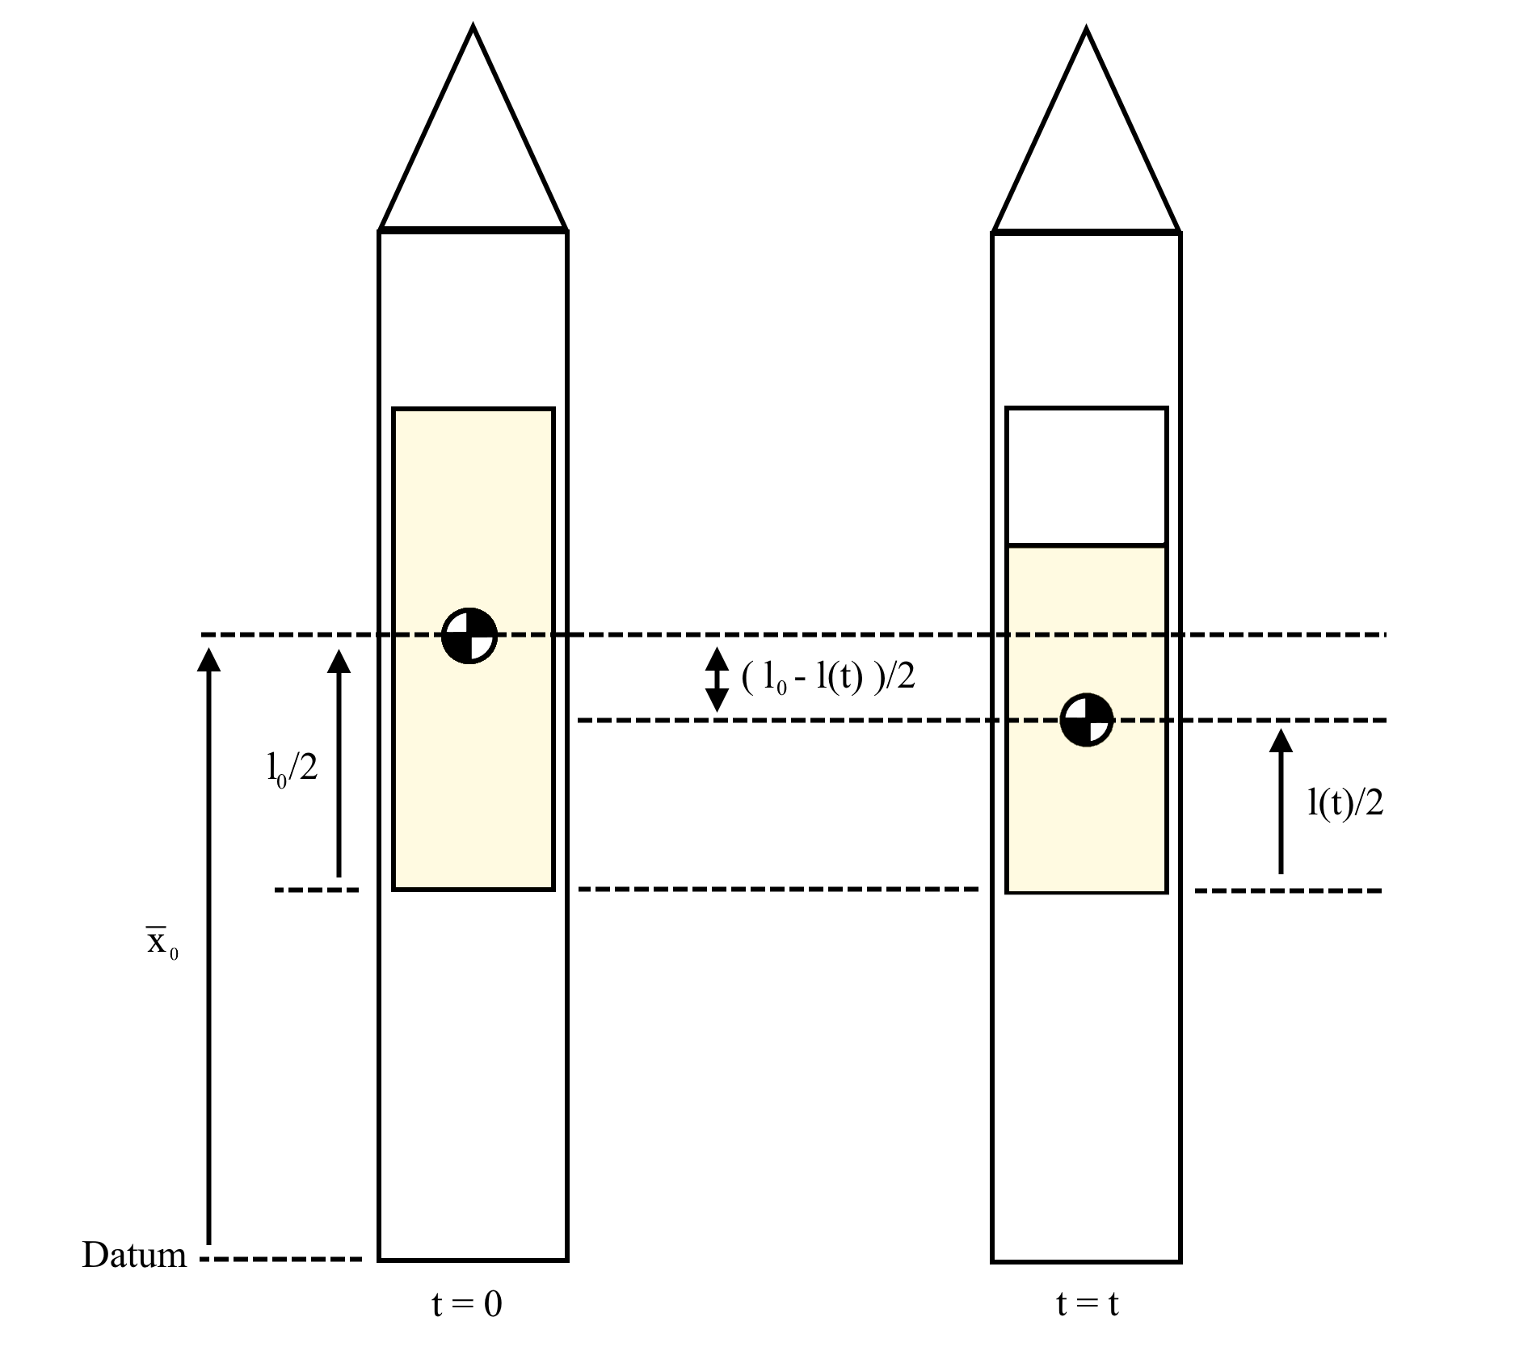

Figure 3: Definitions of lengths

|  |
| --- |
|  |

Knowing the position of the centre of mass, you can now reliably use the parralel axis theorem to find the moments of inertia about other points.

## Solid Fuel

The subscript ‘s’ refers to ‘solid. Note that:

* The mass of the solid cylinder, , is a function of time.
* The inner radius of the cylinder, , is a function of time.
* The length of the solid cylinder, , is a constant.
* The density of the solid cylinder,, is a constant.
* The centre of mass of the solid fuel, , is a constant (since the cylinder’s height is constant).

|  |
| --- |
|  |

The inner radius of the cylinder varies with time, and is given by:

|  |
| --- |
|  |

We can then calculate the moment of inertia around the centre of mass of the solid fuel relatively easily. First, we calculate some intermediate values:

|  |
| --- |
| = the average radius  = the wall thickness |

Then, from the moment of inertia equations for an annular cylinder:

|  |
| --- |
|  |

# References

|  |  |
| --- | --- |
| [1] | Cambridge University Spaceflight, Martlet 4 Specifications. |
| [2] | Cambridge University Engineering Department, Mechanics Databook, 2017. |